Check SU Plots vrs. Project Plots

For reporting purposes, the relationship between your project and your SU table must be one-to-one. Said another way, for each plot in the SU table there must be a corresponding plot in your project. It’s okay to have plots in your project that don’t exist in your SU table, just not the other way around.
Click this button to test for this condition. If you get the message that there is a tree plot for each SU plot, you are golden.
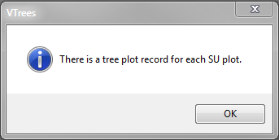
But, if you get a message that you have 1 or more plots in your SU table that aren’t in your project, you’re in trouble.
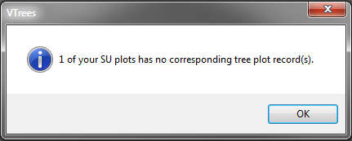

Luckily there is a simple query you can run to spot the problem.
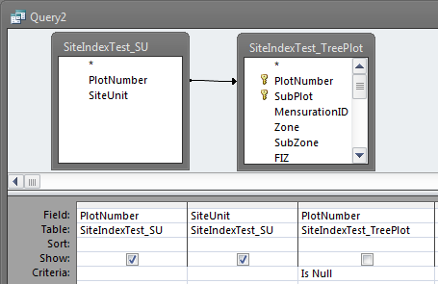
It should display the errant plot(s).
